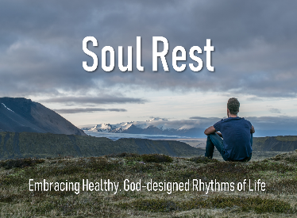
Slowing
Discussion Panel w/the Governance Team
February 16, 2020

Psalm 34:8
Taste and see that the Lord is good;
blessed is the one who takes refuge in him.

Galatians 5:22-23
²² But the fruit of the Spirit is love, joy, peace, forbearance, kindness, goodness, faithfulness, ²³ gentleness and self-control. Against such things there is no law.

Psalm 37:7
Be still before the Lord and wait patiently for him;
do not fret when people succeed in their ways,
when they carry out their wicked schemes.

