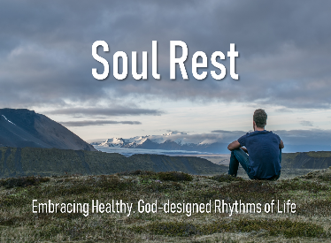
Lord Over Our Time
February 2, 2020

(No Sermon Notes)

1 Peter 1:24-25 For, "All men are like grass and all their glory is like the flowers of the field; the grass withers and the flowers fall, ²⁵ but the word of the Lord stands forever."

Proverbs 27:1 Do not boast about tomorrow, for you do not know what a day may bring forth.

Psalm 90:12 Teach us to number our days aright, that we may gain a heart of wisdom.

James 4:13-15 Now listen, you who say, "Today or tomorrow we will go to this or that city, spend a year there, carry on business and make money." ¹⁴ Why, you do not even know what will happen tomorrow. What is your life? You are a mist that appears for a little while and then vanishes. ¹⁵ Instead, you ought to say, "If it is the Lord's will, we will live and do this or that."

Psalm 139:16 All the days ordained for me were written in your book before one of them came to be.

Ephesians 5:8-20 For you were once darkness, but now you are light in the Lord. Live as children of light ⁹ (for the fruit of the light consists in all goodness, righteousness and truth) ¹⁰ and find out what pleases the Lord. ¹¹ Have nothing to do with the fruitless deeds of darkness, but rather expose them. ¹² For it is shameful even to mention what the disobedient do in secret. ¹³ But everything exposed by the light becomes visible, ¹⁴ for it is light that makes everything visible. This is why it is said: "Wake up, O sleeper, rise from the dead, and Christ will shine on you."
¹⁵ Be very careful, then, how you live-- not as unwise but as wise,
¹⁶ making the most of every opportunity, because the days are evil.
¹⁷ Therefore do not be foolish, but understand what the Lord's will is. ¹⁸ Do not get drunk on wine, which leads to debauchery. Instead, be filled with the Spirit. ¹⁹ Speak to one another with psalms, hymns and spiritual songs. Sing and make music in your heart to the Lord,
²⁰ always giving thanks to God the Father for everything, in the name of our Lord Jesus Christ.

